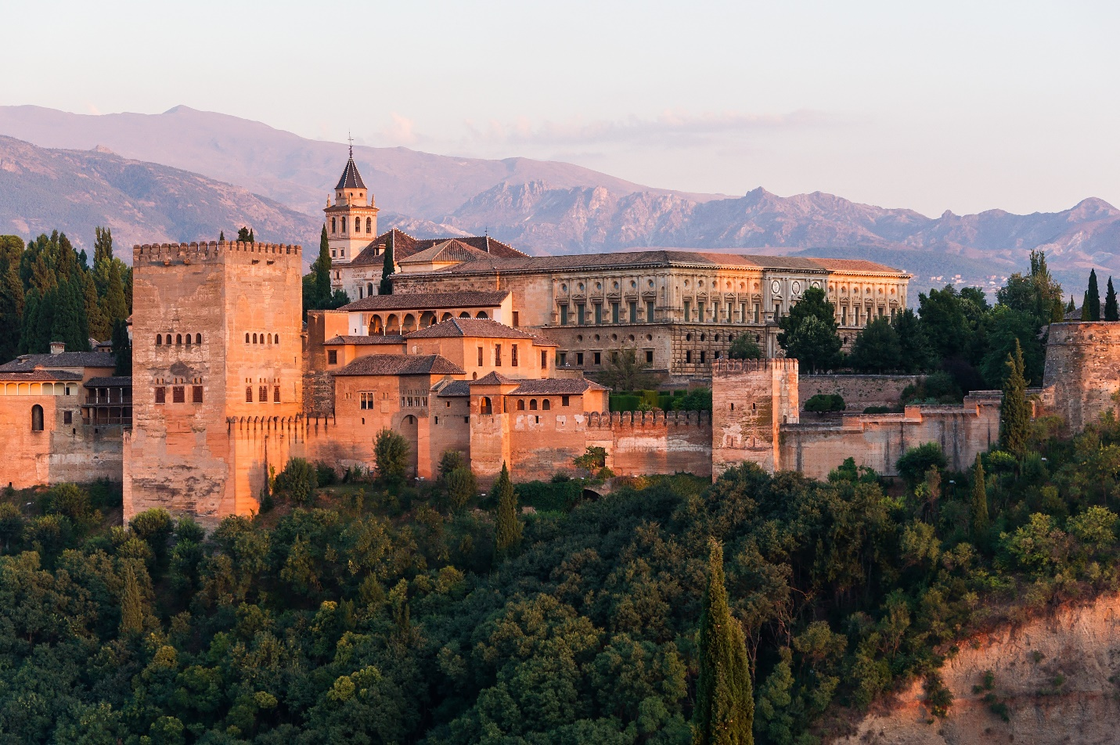

# Alhambra

The **Alhambra** ([/ælˈhæmbrə/](https://en.wikipedia.org/wiki/Help:IPA/English), Spanish: [[aˈlambɾa]](https://en.wikipedia.org/wiki/Help:IPA/Spanish); [Arabic](https://en.wikipedia.org/wiki/Arabic_language): الْحَمْرَاء, [romanized](https://en.wikipedia.org/wiki/Romanization_of_Arabic" \o "Romanization of Arabic): *al-ḥamrāʼ*) is a palace and fortress complex located in [Granada](https://en.wikipedia.org/wiki/Granada), [Spain](https://en.wikipedia.org/wiki/Spain). It is one of the most famous monuments of [Islamic architecture](https://en.wikipedia.org/wiki/Islamic_architecture) and one of the best-preserved palaces of the historic [Islamic world](https://en.wikipedia.org/wiki/Muslim_world), in addition to containing notable examples of Spanish [Renaissance architecture](https://en.wikipedia.org/wiki/Renaissance_architecture).[[1]](https://en.wikipedia.org/wiki/Alhambra#cite_note-UNESCO-1)[[2]](https://en.wikipedia.org/wiki/Alhambra#cite_note-FOOTNOTEBloom2020151-2)[[3]](https://en.wikipedia.org/wiki/Alhambra#cite_note-FOOTNOTEArnold2017234-3)

The complex was begun in 1238 by [Muhammad I Ibn al-Ahmar](https://en.wikipedia.org/wiki/Muhammad_I_of_Granada), the first [Nasrid](https://en.wikipedia.org/wiki/Nasrid_dynasty) emir and founder of the [Emirate of Granada](https://en.wikipedia.org/wiki/Emirate_of_Granada), the last Muslim state of [Al-Andalus](https://en.wikipedia.org/wiki/Al-Andalus).[[3]](https://en.wikipedia.org/wiki/Alhambra#cite_note-FOOTNOTEArnold2017234-3)[[4]](https://en.wikipedia.org/wiki/Alhambra#cite_note-:05222-4) It was built on the Sabika hill, an outcrop of the [Sierra Nevada](https://en.wikipedia.org/wiki/Sierra_Nevada_(Spain)) which had been the site of earlier fortresses and of the 11th-century palace of [Samuel ibn Naghrillah](https://en.wikipedia.org/wiki/Samuel_ibn_Naghrillah).[[4]](https://en.wikipedia.org/wiki/Alhambra#cite_note-:05222-4)[[5]](https://en.wikipedia.org/wiki/Alhambra#cite_note-:24-5) Later Nasrid rulers continuously modified the site. The most significant construction campaigns, which gave the royal palaces much of their defining character, took place in the 14th century during the reigns of [Yusuf I](https://en.wikipedia.org/wiki/Yusuf_I_of_Granada) and [Muhammad V](https://en.wikipedia.org/wiki/Muhammad_V_of_Granada).[[6]](https://en.wikipedia.org/wiki/Alhambra#cite_note-FOOTNOTEBloom2020152-6)[[7]](https://en.wikipedia.org/wiki/Alhambra#cite_note-FOOTNOTEArnold2017234%E2%80%93237-7) After the conclusion of the Christian [Reconquista](https://en.wikipedia.org/wiki/Reconquista) in 1492, the site became the Royal Court of [Ferdinand and Isabella](https://en.wikipedia.org/wiki/Catholic_Monarchs_of_Spain) (where [Christopher Columbus](https://en.wikipedia.org/wiki/Christopher_Columbus) received royal endorsement for his expedition), and the palaces were partially altered. In 1526, [Charles V](https://en.wikipedia.org/wiki/Charles_V,_Holy_Roman_Emperor) commissioned a new [Renaissance-style palace](https://en.wikipedia.org/wiki/Palace_of_Charles_V) in direct juxtaposition with the Nasrid palaces, but it was left uncompleted in the early 17th century. The site fell into disrepair over the following centuries, with its buildings occupied by [squatters](https://en.wikipedia.org/wiki/Squatters). The [troops of Napoleon](https://en.wikipedia.org/wiki/Peninsular_War) destroyed parts of it in 1812. After this, the Alhambra became an attraction for British, American, and other European [Romantic](https://en.wikipedia.org/wiki/Romanticism) travellers. The most influential of them was [Washington Irving](https://en.wikipedia.org/wiki/Washington_Irving), whose [*Tales of the Alhambra*](https://en.wikipedia.org/wiki/Tales_of_the_Alhambra) (1832) brought international attention to the site.[[8]](https://en.wikipedia.org/wiki/Alhambra#cite_note-FOOTNOTEL%C3%B3pez2011301%E2%80%93303-8) The Alhambra was one of the first Islamic monuments to become the object of modern scientific study and has been the subject of numerous restorations since the 19th century.[[9]](https://en.wikipedia.org/wiki/Alhambra#cite_note-FOOTNOTEArnold2017238%E2%80%93239-9)[[10]](https://en.wikipedia.org/wiki/Alhambra#cite_note-FOOTNOTEBloom2020153%E2%80%93155-10) It is now one of Spain's major tourist attractions and a [UNESCO World Heritage Site](https://en.wikipedia.org/wiki/UNESCO_World_Heritage_Site).[[1]](https://en.wikipedia.org/wiki/Alhambra#cite_note-UNESCO-1)

During the Nasrid era, the Alhambra was a self-contained city separate from the rest of Granada below.[[6]](https://en.wikipedia.org/wiki/Alhambra#cite_note-FOOTNOTEBloom2020152-6) It contained most of the amenities of a Muslim city such as a [Friday mosque](https://en.wikipedia.org/wiki/Congregational_mosque), [hammams](https://en.wikipedia.org/wiki/Hammam" \o "Hammam) (public baths), roads, houses, artisan workshops, a [tannery](https://en.wikipedia.org/wiki/Tanning_(leather)), and a sophisticated water supply system.[[11]](https://en.wikipedia.org/wiki/Alhambra#cite_note-FOOTNOTEL%C3%B3pez2011201%E2%80%93215-11)[[12]](https://en.wikipedia.org/wiki/Alhambra#cite_note-FOOTNOTERuggles2008-12) As a royal city and citadel, it contained at least six major palaces, most of them located along the northern edge where they commanded views over the [Albaicín](https://en.wikipedia.org/wiki/Albaic%C3%ADn" \o "Albaicín) quarter.[[6]](https://en.wikipedia.org/wiki/Alhambra#cite_note-FOOTNOTEBloom2020152-6) The most famous and best-preserved are the [Mexuar](https://en.wikipedia.org/wiki/Mexuar" \o "Mexuar), the [Comares Palace](https://en.wikipedia.org/wiki/Court_of_the_Myrtles" \o "Court of the Myrtles), the [Palace of the Lions](https://en.wikipedia.org/wiki/Court_of_the_Lions), and the [Partal Palace](https://en.wikipedia.org/wiki/Partal_Palace" \o "Partal Palace), which form the main attraction to visitors today. The other palaces are known from historical sources and from modern excavations.[[13]](https://en.wikipedia.org/wiki/Alhambra#cite_note-FOOTNOTEL%C3%B3pez2011-13)[[14]](https://en.wikipedia.org/wiki/Alhambra#cite_note-FOOTNOTEArnold2017-14) At the Alhambra's western tip is the [Alcazaba fortress](https://en.wikipedia.org/wiki/Alcazaba_of_the_Alhambra" \o "Alcazaba of the Alhambra). Multiple smaller towers and fortified gates are also located along the Alhambra's walls. Outside the Alhambra walls and located nearby to the east is the [Generalife](https://en.wikipedia.org/wiki/Generalife" \o "Generalife), a former Nasrid country estate and summer palace accompanied by historic [orchards](https://en.wikipedia.org/wiki/Orchard) and modern landscaped gardens.[[15]](https://en.wikipedia.org/wiki/Alhambra#cite_note-FOOTNOTEL%C3%B3pez2011219%E2%80%93225-15)[[12]](https://en.wikipedia.org/wiki/Alhambra#cite_note-FOOTNOTERuggles2008-12)

The architecture of the Nasrid palaces reflects the tradition of [Moorish architecture](https://en.wikipedia.org/wiki/Moorish_architecture) developed over previous centuries.[[16]](https://en.wikipedia.org/wiki/Alhambra#cite_note-FOOTNOTEBloom2020-16)[[14]](https://en.wikipedia.org/wiki/Alhambra#cite_note-FOOTNOTEArnold2017-14) It is characterized by the use of the [courtyard](https://en.wikipedia.org/wiki/Courtyard) as a central space and basic unit around which other halls and rooms were organized.[[17]](https://en.wikipedia.org/wiki/Alhambra#cite_note-FOOTNOTEBloom2020164-17) Courtyards typically had water features at their centre, such as a [reflective pool](https://en.wikipedia.org/wiki/Reflecting_pool) or a fountain. Decoration was focused on the inside of the building and was executed primarily with [tile mosaics](https://en.wikipedia.org/wiki/Zellij) on lower walls and [carved stucco](https://en.wikipedia.org/wiki/Stucco_decoration_in_Islamic_architecture) on the upper walls. [Geometric patterns](https://en.wikipedia.org/wiki/Islamic_geometric_patterns), [vegetal motifs](https://en.wikipedia.org/wiki/Arabesque), and [Arabic](https://en.wikipedia.org/wiki/Arabic) inscriptions were the main types of decorative motifs. Additionally, "stalactite"-like sculpting, known as *[muqarnas](https://en.wikipedia.org/wiki/Muqarnas" \o "Muqarnas)*, was used for three-dimensional features like [vaulted](https://en.wikipedia.org/wiki/Vault_(architecture)) ceilings.

## **History**

### Origins and early history

The evidence for a Roman presence is unclear but archaeologists have found remains of ancient foundations on the Sabika hill.[[20]](https://en.wikipedia.org/wiki/Alhambra#cite_note-FOOTNOTEL%C3%B3pez2011293-20) A fortress or citadel, probably dating from the Visigothic period, existed on the hill in the 9th century.[[5]](https://en.wikipedia.org/wiki/Alhambra#cite_note-:24-5) The first reference to the *Qal‘at al-Ḥamra* was during the battles between the Arabs and the [Muladies](https://en.wikipedia.org/wiki/Muwallad" \o "Muwallad) during the rule of [‘Abdallah ibn Muhammad](https://en.wikipedia.org/wiki/Abdullah_ibn_Muhammad_al-Umawi) (r. 888–912). According to surviving documents from the era, the red castle was quite small, and its walls were not capable of deterring an army intent on conquering. The first reference to *al-Ḥamrāʼ* came in lines of poetry attached to an arrow shot over the ramparts, recorded by [Ibn Hayyan](https://en.wikipedia.org/wiki/Ibn_Hayyan) (d. 1076):

"Deserted and roofless are the houses of our enemies;  
  Invaded by the autumnal rains, traversed by impetuous winds;  
Let them within the red castle (Kalat al hamra) hold their mischievous councils;  
  Perdition and woe surround them on every side."[[21]](https://en.wikipedia.org/wiki/Alhambra#cite_note-21)

At the beginning of the 11th century, the region of Granada was dominated by the Zirids, a [Sanhaja](https://en.wikipedia.org/wiki/Sanhaja" \o "Sanhaja) [Berber](https://en.wikipedia.org/wiki/Berbers) group and offshoot of the [Zirids](https://en.wikipedia.org/wiki/Zirid_dynasty" \o "Zirid dynasty) who ruled parts of [North Africa](https://en.wikipedia.org/wiki/North_Africa). When the [Caliphate of Córdoba](https://en.wikipedia.org/wiki/Caliphate_of_C%C3%B3rdoba) collapsed after 1009 and the [Fitna (civil war)](https://en.wikipedia.org/wiki/Fitna_of_al-Andalus" \o "Fitna of al-Andalus) began, the Zirid leader [Zawi ben Ziri](https://en.wikipedia.org/wiki/Zawi_ben_Ziri" \o "Zawi ben Ziri) established an independent kingdom for himself, the [Taifa of Granada](https://en.wikipedia.org/wiki/Taifa_of_Granada" \o "Taifa of Granada).[[4]](https://en.wikipedia.org/wiki/Alhambra#cite_note-:05222-4) The Zirids built their citadel and palace, known as the *al-Qaṣaba al-Qadīma* ("Old Citadel" or "Old Palace"), on the hill now occupied by the [Albaicín](https://en.wikipedia.org/wiki/Albaic%C3%ADn" \o "Albaicín) neighbourhood.[[4]](https://en.wikipedia.org/wiki/Alhambra#cite_note-:05222-4)[[5]](https://en.wikipedia.org/wiki/Alhambra#cite_note-:24-5) It was connected to two other fortresses on the Sabika and Mauror hills to the south.[[5]](https://en.wikipedia.org/wiki/Alhambra#cite_note-:24-5) On the [Darro River](https://en.wikipedia.org/wiki/Darro_(river)" \o "Darro (river)), between the Zirid citadel and the Sabika hill, was a [sluice gate](https://en.wikipedia.org/wiki/Sluice) called *Bāb al-Difāf* ("Gate of the Tambourines"),[[a]](https://en.wikipedia.org/wiki/Alhambra#cite_note-23) which could be closed to retain water if needed.[[22]](https://en.wikipedia.org/wiki/Alhambra#cite_note-FOOTNOTER%C4%97klaityt%C4%972021443%E2%80%93445-22)[[23]](https://en.wikipedia.org/wiki/Alhambra#cite_note-FOOTNOTERodgersCavendish202121-24) This gate was part of the fortification connecting the Zirid citadel with the fortress on the Sabika hill and it also formed part of a *coracha* (from Arabic *qawraja*), a type of fortification allowing soldiers from the fortress to access the river and bring back water even during times of siege.[[22]](https://en.wikipedia.org/wiki/Alhambra#cite_note-FOOTNOTER%C4%97klaityt%C4%972021443%E2%80%93445-22) The Sabika hill fortress, also known as *al-Qasaba al-Jadida* ("the New Citadel"), was later used for the foundations of the current [Alcazaba](https://en.wikipedia.org/wiki/Alcazaba_of_the_Alhambra" \o "Alcazaba of the Alhambra) of the Alhambra.[[5]](https://en.wikipedia.org/wiki/Alhambra#cite_note-:24-5)[[24]](https://en.wikipedia.org/wiki/Alhambra#cite_note-FOOTNOTEArnold2017149-25)[[25]](https://en.wikipedia.org/wiki/Alhambra#cite_note-FOOTNOTEL%C3%B3pez201181,_293-26) Under the Zirid kings [Habbus ibn Maksan](https://en.wikipedia.org/wiki/Habbus_al-Muzaffar" \o "Habbus al-Muzaffar) and [Badis](https://en.wikipedia.org/wiki/Badis_ibn_Habus" \o "Badis ibn Habus), the most powerful figure in the kingdom was the [Jewish](https://en.wikipedia.org/wiki/Jews) administrator known as [Samuel ha-Nagid](https://en.wikipedia.org/wiki/Samuel_ibn_Naghrillah) (in [Hebrew](https://en.wikipedia.org/wiki/Hebrew_language)) or Isma'il ibn Nagrilla (in Arabic).[[26]](https://en.wikipedia.org/wiki/Alhambra#cite_note-:4-27) Samuel built his own palace on the Sabika hill, possibly on the site of the current palaces, although nothing remains of it. It reportedly included gardens and water features.